**Working With Some Intigers**

Generate 100 random integers in the interval between 0 and 132. Print on the Console these from them that:

1. are having even indexes;
2. are odd and having odd indexes;
3. are divided to 3 without reminder;
4. are divided to 7 and have 1 as reminder;
5. are in the interval between 26 and 100;
6. are not in the interval between 26 and 100.

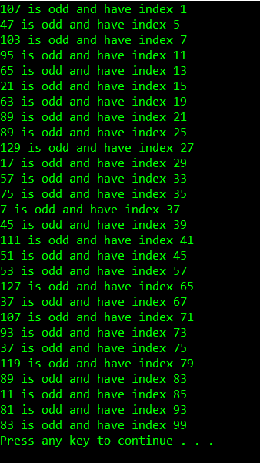This picture is from example b).